Technical Drawing Assignment

Using blocks lettered A, B, C, F, I and Z reproduce them to the exact measurements using the scale one cm is equal to 5 mm.
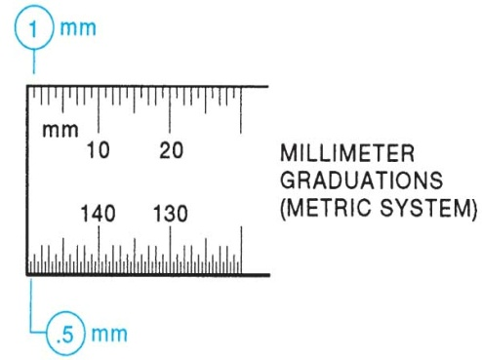
The following must be included in your drawing
- Four different views
- All Dimensions
- Name of view (example: front, back, top, bottom, right side and left side)
- Include any hidden lines
- Drawings must be in pencil and all lines are to be drawn with a ruler

